Year 9 Mathematics Curriculum Medium-Term Plan HT4

.

The most important purpose of curriculum planning documents is that they will specify everything that students should learn. What is not specified is far less likely to be taught, let alone assessed appropriately.

Term | Half Term | Year 9 Overview
Autumn | HT1 | LO1: Place Value  LO2: Ordering decimals & Integers.  LO3: Calculations with negative numbers.  LO4: BIDMAS  LO5: Powers & Roots & Primes and proof  LO6: Standard Form
 | HT2 | LO1: Algebraic expressions.  LO2: Solving Equations  LO3: Writing formulas  LO4: Position to term rule.
Spring | HT3 | LO1: Equivalent fractions  LO2: Adding and subtracting Fractions  L03: Mixed numbers & Improper fractions.  LO4: Multiplying whole numbers by fractions.  LO5: Simplifying Ratio.  LO6: Percentage Change.
 | HT4 | LO1: Properties of triangles & Quadrilaterals.  LO2: Deduction  LO3: Rotation and Translation  LO4: Vectors
Summer | HT5 | LO1: Probability Scale.  LO2: Sample space diagram.  LO3: Venn Diagrams.  LO4: Transformations.  LO5: Three dimensional shape.  LO6: Pythagoras
 | HT 6 | LO1: Scatter graphs & Correlation.  LO2: Lines of best fit  LO3: Mean, median, mode & Ranges.  LO4: Ungrouped& Grouped frequency tables.  LO5: Pictograms & Bar Charts.  LO6: Construction

Term & Year Group | Spring Term 4
Links to the National Curriculum/Examination Specification | - Move freely between different numerical, algebraic, graphical and diagrammatic representations [for example, equivalent fractions, fractions and decimals, and equations and graphs];  - Use language and properties precisely to analyse numbers, algebraic expressions, 2-D and 3-D shapes, probability and statistics;  - Extend their understanding of the number system; make connections between number relationships, and their algebraic and graphical representations;  - Make and test conjectures about patterns and relationships; look for proofs or counter- examples;  - Begin to reason deductively in geometry, number and algebra, including using geometrical constructions;  - Model situations or procedures by translating them into algebraic expressions or formulae and by using graphs;  - Use scale factors, scale diagrams and maps;  - Derive and apply formulae to calculate and solve problems involving: perimeter and area of triangles, parallelograms, trapezia, volume of cuboids (including cubes) and other prisms (including cylinders);  - Draw and measure line segments and angles in geometric figures, including interpreting scale drawings;  - Describe, sketch and draw using conventional terms and notations: points, lines, parallel lines, perpendicular lines, right angles, regular polygons, and other polygons that are reflectively and rotationally symmetric;  - Use the standard conventions for labelling the sides and angles of triangle ABC, and know and use the criteria for congruence of triangles;  - Derive and illustrate properties of triangles, quadrilaterals, circles, and other plane figures [for example, equal lengths and angles] using appropriate language and technologies;  - Identify properties of, and describe the results of, translations, rotations and reflections applied to given figures;  - Apply the properties of angles at a point, angles at a point on a straight line, vertically opposite angles;  - Understand and use the relationship between parallel lines and alternate and corresponding angles;  - Derive and use the sum of angles in a triangle and use it to deduce the angle sum in any polygon, and to derive properties of regular polygons;  - Interpret mathematical relationships both algebraically and geometrically;  - Calculate and solve problems involving: perimeters of 2-D shapes (including circles), areas of circles and composite shapes;  - Describe, sketch and draw using conventional terms and notations: points, lines, parallel lines, perpendicular lines, right angles, regular polygons, and other polygons that are reflectively and rotationally symmetric;  - Use the standard conventions for labelling the sides and angles of triangle ABC, and know and use the criteria for congruence of triangles;  - Identify properties of, and describe the results of, translations, rotations and reflections applied to given figures;  - Identify and construct congruent triangles, and construct similar shapes by enlargement, with and without coordinate grids;  - Develop their mathematical knowledge, in part through solving problems and evaluating the outcomes, including multi-step problems;  - Develop their use of formal mathematical knowledge to interpret and solve problems, including in financial mathematics;  - Begin to model situations mathematically and express the results using a range of formal mathematical representations;  - Select appropriate concepts, methods and techniques to apply to unfamiliar and non- routine problems.
Overall Aims | What are the overarching aims for students in terms of the key substantive knowledge components, disciplinary knowledge (skills) and understanding they will develop?  By the end of this unit students should know and be able to apply a variety of angle facts to help them find missing angles. They should have increased their knowledge and understanding of transformations and should be able to describe as well as undertake different transformations. The main knowledge is:  - Angles in a triangle and quadrilateral  - Angles on a line and around a point  - Vertically opposite and corresponding angles  - Alternate angles and co-interior angles  - Interior angles of a polygon with n sides  - Exterior angles of a polygon  - Calculating the number of sides of a polygon given partial interior/exterior angles  - Rotating a shape by 90, 180, 270 degrees around different points of rotation using tracing paper; describing the degree of rotation  - Translating a shape by a given vector  - Representing vectors visually and numerically  - Changing the direction and magnitude of a vector visually and numerically  - Vector addition and subtraction  - Multiplying a vector by a scalar
Prior learning & common misconceptions | What learning has come before this unit that should be drawn upon to secure deeper understanding and make connections?  Students will have covered some angle facts in years 7 and 8 so it is important to ascertain which ones they remember and build on these. Give students problems of increasing complexity where there is more than one way to find a solution and also multi-step problems. Interior angles of polygons with n sides and exterior angles have not been covered in years 7 and 8.  What are the common misconceptions that hinder progress?  Students struggle to visualise transformations. With rotations they should be encouraged to use tracing paper to help.  When describing transformations students need to name the type of transformation and then the features. If it is a translation they need to say that and then describe the vector. If it is a rotation, they need to say that and then describe the amount of turn, the direction and the centre.
Assessment | How will student progress be assessed through both formative & summative assessments?  Lesson by Lesson  Use of mini-whiteboards  Low stakes quizzes for connect activities to embed prior learning – especially with mathematical terminology  Daily opportunities for retrieval practice in recall activity at beginning of lesson  Pupils will be regularly assessed through classwork, features of this include routine starter tasks that allow a revisit to previously taught aspects of the curriculum to improve recall;  Progress Checks  Low stake quizzes eg Bingo  Skillful Q&A by teachers is a regular feature of maths lessons to assess understanding, inform activities, and identify any misconceptions.  Individual feedback provided to students identifying next steps  End of Topic  Half termly assessments, with QLA produced (not yet at KS3), used formatively to inform recall tasks  Individual feedback provided to students identifying next steps
Language & Reading | What is the provision to…  Talk like a specialist  - Students will be introduced to key terminology and be challenged to use this at every opportunity  Write like a specialist.  - Include reason and examples in answers and write algebraically and graphically  Read like a specialist  - Given a written problem, interpret and use information to navigate an efficient pathway that results in an accurate solution  - Read and interpret mathematics written algebraically or graphically
Links to SMSC/SRE/British Values | Spiritual Education  - We strive to enable each of our students to use their imagination and creativity to explore ideas while learning mathematics by: identifying and applying patterns and rules to everyday problem-solving;  - Writing their own problems and challenges that use those patterns or rules.  Moral Education  - Broadening the pupils' understanding of the consequences of actions: Eg. If you perform a particular action to one number, will the same outcome apply to other numbers? Is it always the case? ‘Sometimes, always, never’ statements will be explored and addressed.  Social Education Developing personal qualities and using social skills:  - Working in pairs or groups to solve problems; Perseverance when struggling to answer questions; not being afraid to try – it’s ok to be wrong, it’s not ok not to try; taking turns when playing maths games. Participating, co-operating and resolving conflicts: as above, but also ‘X thinks ___, Y thinks ___, who is right?’ type questions.  Cultural Education  - Understanding and appreciating personal influences: taking into account other people’s views and understanding how to express own views. Eg. How to explain to someone where they may have gone wrong in a question.  British Values  Democracy  - Take into account the views of others in shared activities. Voting when collecting data.  The Rule of Law  - Undertake safe practices, following class rules during tasks and activities for the benefit of all. Understand the consequences if rules are not followed.  Individual Liberty  - Work within boundaries to make safe choices during practical activities. Make your own choices within data handling activities.  Tolerance of those with different faiths and beliefs  - Use maths to learn about different faiths and cultures around the world. Eg. looking at patterns/shapes within Islam / Hindu religions.  Mutual Respect  - To behave appropriately, allowing all participants the opportunity to work effectively. Take turns and share equipment. Review each other’s work respectfully. Work collaboratively on projects/problems, help and advise others

Knowledge Components at a Glance

Composite Performance: Shapes and Geometry

I can describe and implement different transformations.
I can describe a translation using a vector.
I can translate a shape by a given vector.
I know how to find the sum of interior angles for shapes of n sides.
I know that exterior angles of any polygon add to 360.

I can recognise rotational symmetry and a translation.
I know what a vector is.
I know what a translation is.
Transformations
Angle Facts
I can apply my knowledge of angles and shapes to more complex problems

Given a transformation I can decide whether it is a reflection, rotation or a translation and provide reasons.

I can find interior and exterior angles in polygons, both regular and irregular.

Week/ Lesson  Key Question? | Key knowledge components & Lesson Outcomes  What do students need to know & what should they be able to do? | Pedagogy & Assessment– How do we teach and assess this at Coal Clough Academy? Strategies to support students knowing more & remembering more  Suggested teaching activities & resources including ‘non-negotiables’ for delivery e.g. minimum of two assessment style questions per week, minimum of one practical per week…
Week 1/ Lesson 1 | What are the key knowledge components students must be taught this lesson?  - I can apply my knowledge of angles and shapes to more complex problems  What are the learning outcomes for this lesson?  - Angles in a triangle and quadrilateral  Key Questions:  What do I call the angles on the inside of the triangle/quadrilateral?  What do the angles of a triangle add up to?  What do the angles of any quadrilateral add up to?  Which angle rules can I use to help me find this missing angles? Are there any other ways I can find the missing angle?  What type of triangle is this? How do I know?  What notation do we use for equal sides? Equal angles? | Key vocabulary for this lesson & how it will be introduced?  Quadrilateral, square, rectangle, kite, rhombus, parallelogram, triangle, vertex, vertices, interior angle, exterior angle, equilateral, isosceles, scalene  Recall activity: 4 Qs (last lesson, last week, last month, last topic); Use questions from assessments (informal and formal) and QLA.  Suggested teaching activities, pedagogy and assessment to inform next steps:  Only start with the paper activity below if students have no prior knowledge of angles in a triangle. If they can remember angles in a triangle move straight to angles in a quadrilateral.  Give each student a pre-cut triangle which are all different. Get them to tear of the vertices and join the angles together so that they can see that whatever the triangle, its angles always add to 180º  Repeat the above with different quadrilaterals so that they can all see that the interior angles of a quadrilateral add to 360º  Continue to use angle notation to develop students’ fluency with mathematical language using questions such as:  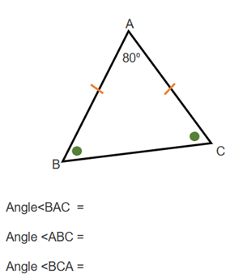  See if students can combine angle facts to calculate a missing angle eg.,  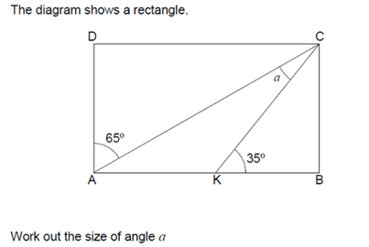
Addressing gaps  SEND learners have a Pupil Passport that informs strategies for learning bespoke to that student.  Staff must make sure they are familiar with the various strategies involved and embed these in their lessons.  Ensure students know the names of and understand the differences between types of triangles. They should also be familiar with the notation used for equal angles and sides.  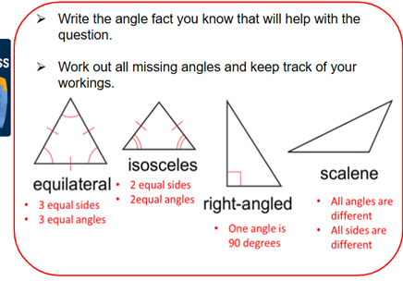 |  | Deepening knowledge  Use some questions with angles on a line and around a point to pre-teach the next lesson to help you guage the starting point for the class.

Week/ Lesson  Key Question? | Key knowledge components & Lesson Outcomes  What do students need to know & what should they be able to do? | Pedagogy & Assessment– How do we teach and assess this at Coal Clough Academy? Strategies to support students knowing more & remembering more  Suggested teaching activities & resources including ‘non-negotiables’ for delivery e.g. minimum of two assessment style questions per week, minimum of one practical per week…
Week 1/ Lesson 2 | What are the key knowledge components students must be taught this lesson?  - I can apply my knowledge of angles and shapes to more complex problems  What are the learning outcomes for this lesson?  - Angles on a line and around a point  Key Questions:  If the angles on a line make up a semi-circle so add up to 180º, what about angles around a point? How many degrees would you predict they add up to? | Key vocabulary for this lesson & how it will be introduced?  Equilateral, isosceles, scalene,  Recall activity: 4 Qs (last lesson, last week, last month, last topic); Use questions from assessments (informal and formal) and QLA.  Suggested teaching activities, pedagogy and assessment to inform next steps:  Students will have come across both angles in a line and around a point in years 7 and 8 so start by checking what they have remembered  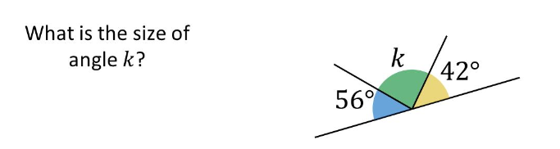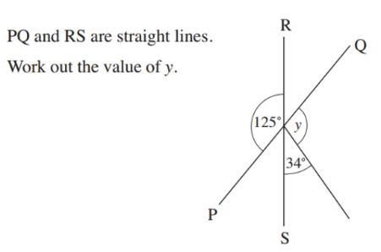  Check students can read and use shape notation for equal angles and sides.
Addressing gaps  SEND learners have a Pupil Passport that informs strategies for learning bespoke to that student.  Staff must make sure they are familiar with the various strategies involved and embed these in their lessons.  Don’t move on to angles around a point unless students are secure with angles on a line. |  | Deepening knowledge  Give questions where students have to use more than one fact to find missing angles or there’s more than one missing angle to find eg  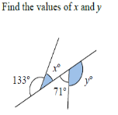

Week/ Lesson  Key Question? | Key knowledge components & Lesson Outcomes  What do students need to know & what should they be able to do? | Pedagogy & Assessment– How do we teach and assess this at Coal Clough Academy? Strategies to support students knowing more & remembering more  Suggested teaching activities & resources including ‘non-negotiables’ for delivery e.g. minimum of two assessment style questions per week, minimum of one practical per week…
Week 1/ Lesson 3 | What are the key knowledge components students must be taught this lesson?  - I can apply my knowledge of angles and shapes to more complex problems  What are the learning outcomes for this lesson?  - Vertically opposite and corresponding angles  Key Questions:  How would you find out how big angle ‘a’ is?  So how big would angle ‘b’ be? How do you know? Is there another way we can work out angle b?  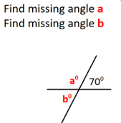  What are the arrows on these lines for? What do they mean?  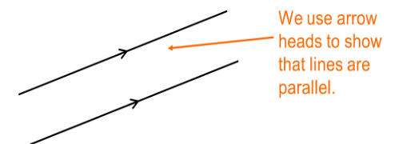  How would we show these sides are equal in length? | Key vocabulary for this lesson & how it will be introduced?  Parallel, perpendicular, vertically opposite, corresponding, transversal  Recall activity: 4 Qs (last lesson, last week, last month, last topic); Use questions from assessments (informal and formal) and QLA.  Suggested teaching activities, pedagogy and assessment to inform next steps:  Use angles on a line to teach vertically opposite angles as normally students can deduce vertically opposite from this.  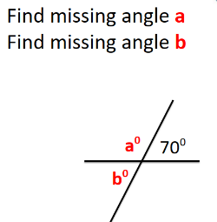  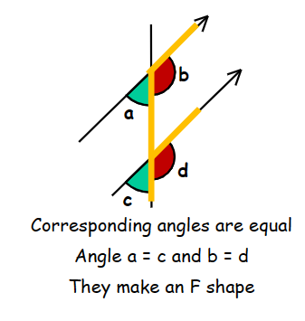  Spend time allowing students to recognize corresponding angles amongst a few angles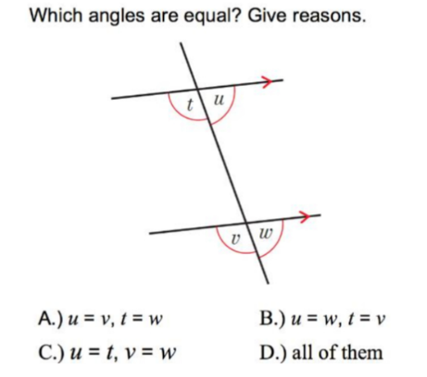
Addressing gaps  SEND learners have a Pupil Passport that informs strategies for learning bespoke to that student.  Staff must make sure they are familiar with the various strategies involved and embed these in their lessons.  Students need to be able to visualise corresponding angles but in different orientations eg the ‘F’ will be back to front and upside down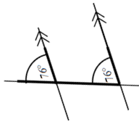 |  | Deepening knowledge  Give questions where students need to use a variety of angle facts to find missing angles

Week/ Lesson  Key Question? | Key knowledge components & Lesson Outcomes  What do students need to know & what should they be able to do? | Pedagogy & Assessment– How do we teach and assess this at Coal Clough Academy? Strategies to support students knowing more & remembering more  Suggested teaching activities & resources including ‘non-negotiables’ for delivery e.g. minimum of two assessment style questions per week, minimum of one practical per week…
Week 2/ Lesson 1 | What are the key knowledge components students must be taught this lesson?  - I can apply my knowledge of angles and shapes to more complex problems  What are the learning outcomes for this lesson?  - Alternate angles and co-interior angles  Key Questions:  Where are the corresponding angles?  These 2 angles are alternate – what do you think the rule is for them? How do you know?  What shape to alternate angles make?  What shape do co-interior angles make?  Where is the C-shape in this question?  Where is the z shape in this question?  Give questions that incorporate corresponding, alternate and co-interior angles eg  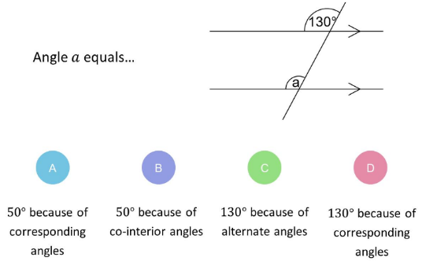  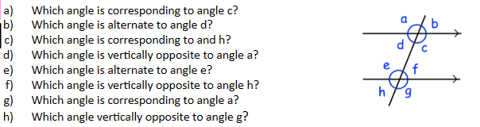 | Key vocabulary for this lesson & how it will be introduced?  Parallel, perpendicular, vertically opposite, corresponding, alternate, co-interior, transversal  Recall activity: 4 Qs (last lesson, last week, last month, last topic); Use questions from assessments (informal and formal) and QLA.  Suggested teaching activities, pedagogy and assessment to inform next steps:  Start with a re-cap on corresponding angles and link this into alternate and co-interior angles. Some students will be able to predict the rules so use this in the lesson.  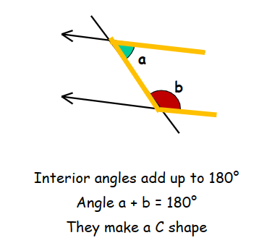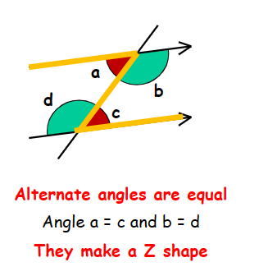  Students need to be able to visualise the Z shape so expose them to it in different orientations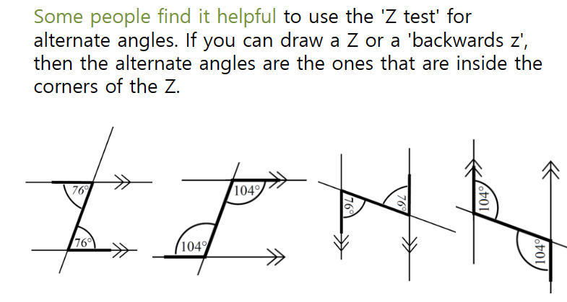  Students need to be able to visualise co-interior angles  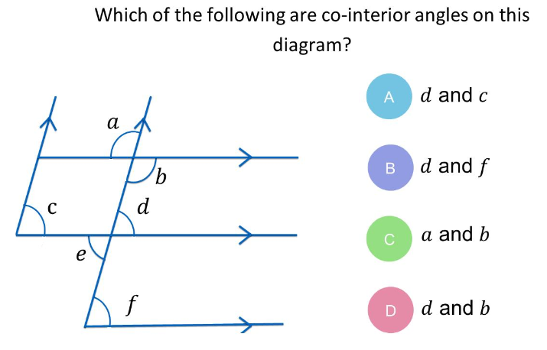
Addressing gaps  SEND learners have a Pupil Passport that informs strategies for learning bespoke to that student.  Staff must make sure they are familiar with the various strategies involved and embed these in their lessons. |  | Deepening knowledge  Give cross-strand questions such as algebraic angle facts  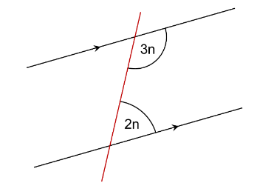

Week/ Lesson  Key Question? | Key knowledge components & Lesson Outcomes  What do students need to know & what should they be able to do? | Pedagogy & Assessment– How do we teach and assess this at Coal Clough Academy? Strategies to support students knowing more & remembering more  Suggested teaching activities & resources including ‘non-negotiables’ for delivery e.g. minimum of two assessment style questions per week, minimum of one practical per week…
Week 2/ Lesson 2 | What are the key knowledge components students must be taught this lesson?  - I know how to find the sum of interior angles for shapes of n sides.  What are the learning outcomes for this lesson?  - Interior angles of a polygon with n sides  Key Questions:  What is a polygon?  What do we mean by a regular polygon?  What do we mean by irregular polygon?  How many triangles can we split the pentagon into?  Each triangle’s angles add to 180º so if there’s 3 triangles what will the interior angles of the pentagon add to? | Key vocabulary for this lesson & how it will be introduced?  Polygon, regular, irregular, quadrilateral, pentagon, hexagon, heptagon, octagon, nonagon, decagon, endecagon, dodecagon  Recall activity: 4 Qs (last lesson, last week, last month, last topic); Use questions from assessments (informal and formal) and QLA.  Suggested teaching activities, pedagogy and assessment to inform next steps:  Start by clarifying the differences between regular/irregular polygons  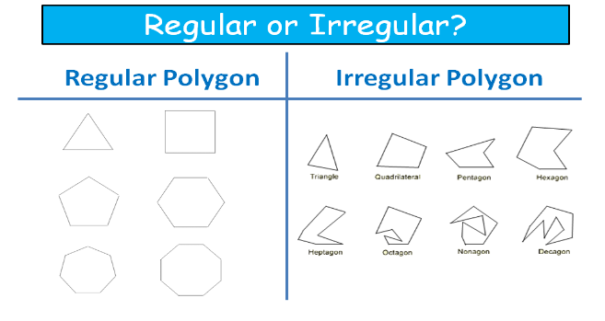  Introduce sum of interior angles for any polygon by splitting polygons into triangles and using angles of a triangle add to 180.  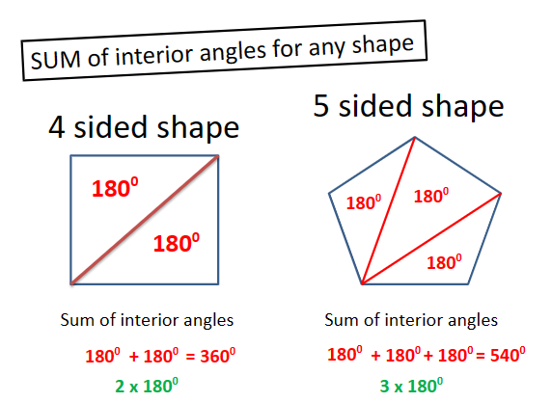  Get students to identify angle sum for polygons up to n sides by splitting into triangles and then adding the triangles up. Then get them to generalize between the number of sides of a polygon and how many triangles there will be eg n-2 so the angle sum will be (n-2) x 180. If they want to find the size of each angle in a regular polygon they just divide the angle sum by the number of sides. Check they understand by getting them to find the size of interior angles of some regular polygons (using a calculator)  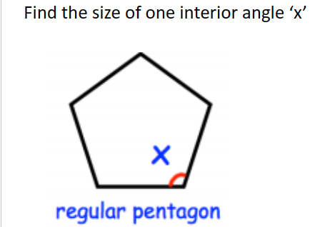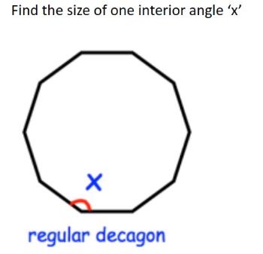
Addressing gaps  SEND learners have a Pupil Passport that informs strategies for learning bespoke to that student.  Staff must make sure they are familiar with the various strategies involved and embed these in their lessons. |  | Deepening knowledge  Get students to calculate missing angles in irregular polygons by calculating the angle sum and subtracting the known angles from that. eg  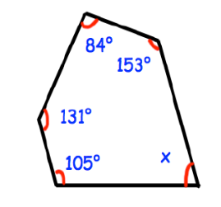  Get students to combine angle facts to calculate missing angles eg  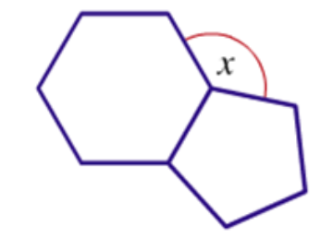

Week/ Lesson  Key Question? | Key knowledge components & Lesson Outcomes  What do students need to know & what should they be able to do? | Pedagogy & Assessment– How do we teach and assess this at Coal Clough Academy? Strategies to support students knowing more & remembering more  Suggested teaching activities & resources including ‘non-negotiables’ for delivery e.g. minimum of two assessment style questions per week, minimum of one practical per week…
Week 2/ Lesson 3 | What are the key knowledge components students must be taught this lesson?  - I know that exterior angles of any polygon add to 360.  - I can find interior and exterior angles in polygons, both regular and irregular.  What are the learning outcomes for this lesson?  - Exterior angles of a polygon  Key Questions:  Where is the exterior angle? What do we mean by an exterior angle?  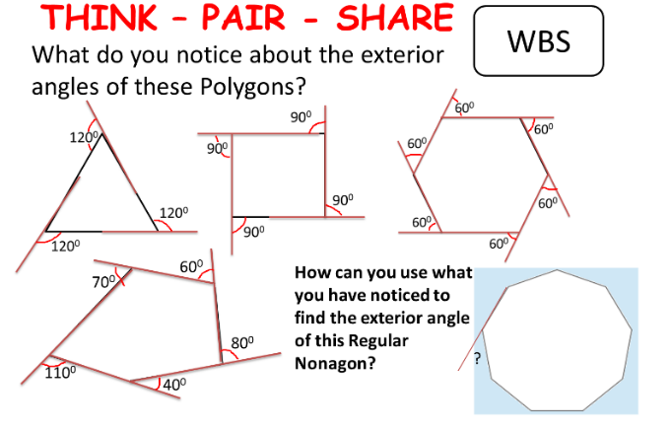 | Key vocabulary for this lesson & how it will be introduced?  Interior angle, exterior angle, regular, irregular, polygon  Recall activity: 4 Qs (last lesson, last week, last month, last topic); Use questions from assessments (informal and formal) and QLA.  Suggested teaching activities, pedagogy and assessment to inform next steps:  Clarify what we mean by an exterior angle as it is the angle formed by a side of a polygon being extended and the next side of the polygon eg  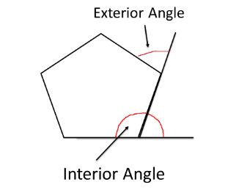  Link the lesson into interior angles to help students calculate the exterior angles and from that deduce that exterior angles of any polygon add up to 360º.  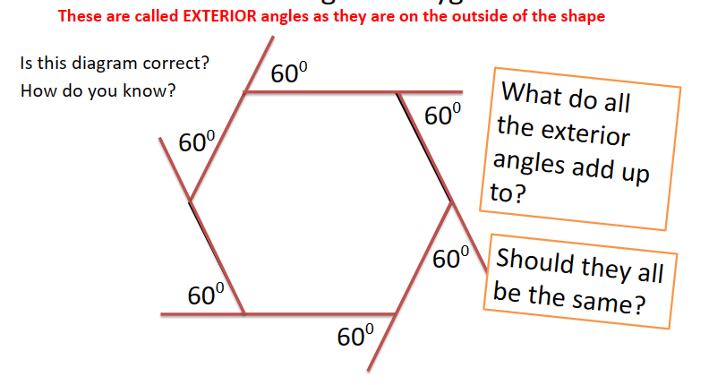  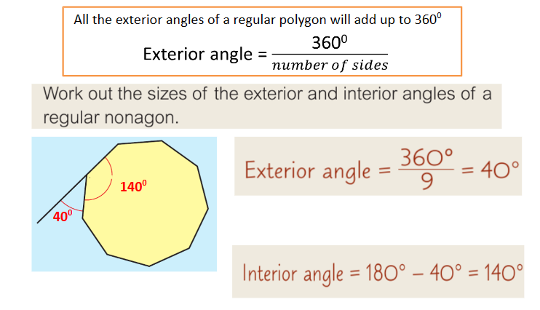  Give students questions involving interior and exterior angles eg., 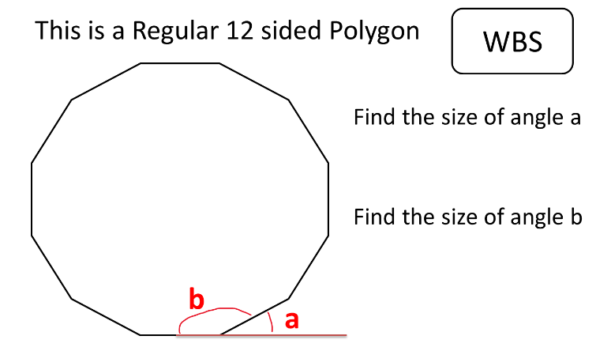
Addressing gaps  SEND learners have a Pupil Passport that informs strategies for learning bespoke to that student.  Staff must make sure they are familiar with the various strategies involved and embed these in their lessons. |  | Deepening knowledge  Give questions where the polygons are irregular  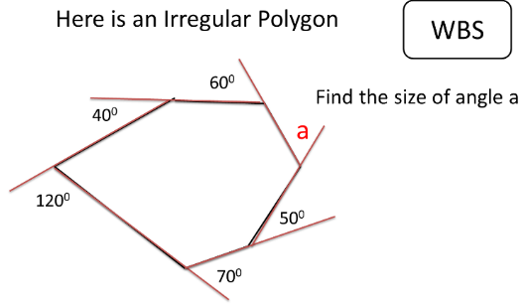
Week 3: Assessment Week

Week/ Lesson  Key Question? | Key knowledge components & Lesson Outcomes  What do students need to know & what should they be able to do? | Pedagogy & Assessment– How do we teach and assess this at Coal Clough Academy? Strategies to support students knowing more & remembering more  Suggested teaching activities & resources including ‘non-negotiables’ for delivery e.g. minimum of two assessment style questions per week, minimum of one practical per week…
Week 4/ Lesson 1 | What are the key knowledge components students must be taught this lesson?  - I know that exterior angles of any polygon add to 360.  - I can find interior and exterior angles in polygons, both regular and irregular.  What are the learning outcomes for this lesson?  - Calculating the number of sides of a polygon given partial interior/exterior angles  Key Questions:  What would the exterior angle of this polygon be? How do you know? What do the exterior angles of a polygon add up to?  If this is a regular polygon, and each exterior angle is 30º how many sides does the polgon have? How do you know?  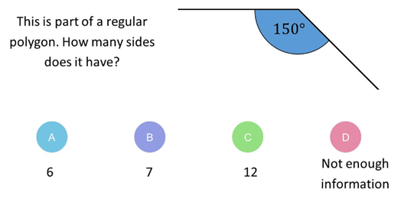 | Key vocabulary for this lesson & how it will be introduced?  Interior angle, exterior angle, regular, irregular, polygon  Recall activity: 4 Qs (last lesson, last week, last month, last topic); Use questions from assessments (informal and formal) and QLA.  Suggested teaching activities, pedagogy and assessment to inform next steps:  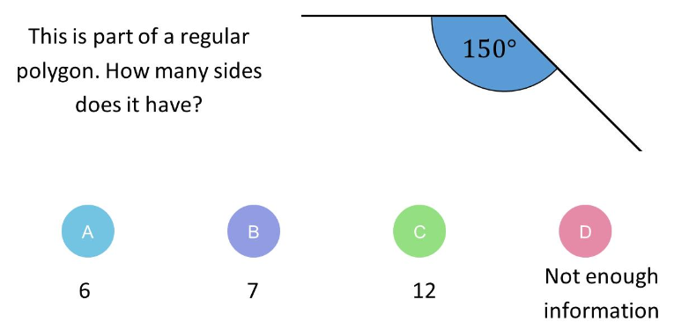
Addressing gaps  SEND learners have a Pupil Passport that informs strategies for learning bespoke to that student.  Staff must make sure they are familiar with the various strategies involved and embed these in their lessons.  Don’t move onto this lesson unless students are secure with finding exterior angles from the previous lesson. |  | Deepening knowledge

Week/ Lesson  Key Question? | Key knowledge components & Lesson Outcomes  What do students need to know & what should they be able to do? | Pedagogy & Assessment– How do we teach and assess this at Coal Clough Academy? Strategies to support students knowing more & remembering more  Suggested teaching activities & resources including ‘non-negotiables’ for delivery e.g. minimum of two assessment style questions per week, minimum of one practical per week…
Week 4/ Lesson 2 | What are the key knowledge components students must be taught this lesson?  - I can recognise rotational symmetry and a translation.  - I can describe and implement different transformations.  What are the learning outcomes for this lesson?  - Rotating a shape by 90, 180, 270 degrees around different points of rotation using tracing paper; describing the degree of rotation  Key Questions:  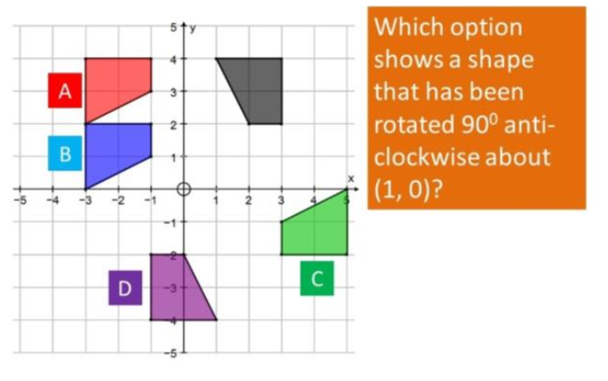  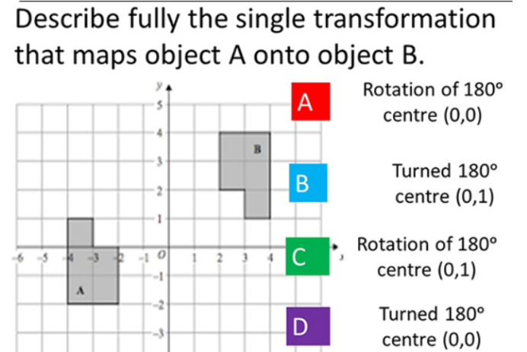 | Key vocabulary for this lesson & how it will be introduced?  Transformation, reflection, rotation, centre of rotation, clockwise, anticlockwise, object, image  Recall activity: 4 Qs (last lesson, last week, last month, last topic); Use questions from assessments (informal and formal) and QLA.  Suggested teaching activities, pedagogy and assessment to inform next steps:  Get students to use tracing paper, especially when they cannot visualise the image; start with simple rotations and then give them of increasing difficulty. 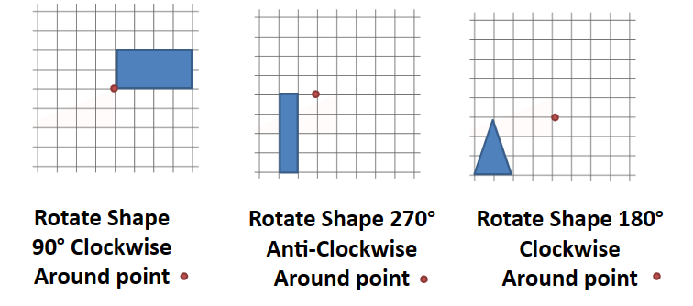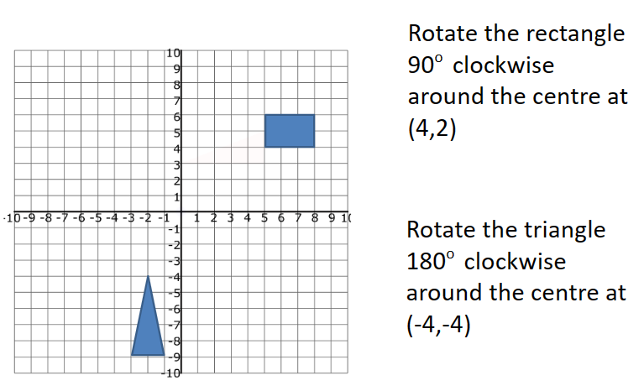  Then move students to descibing rotations:  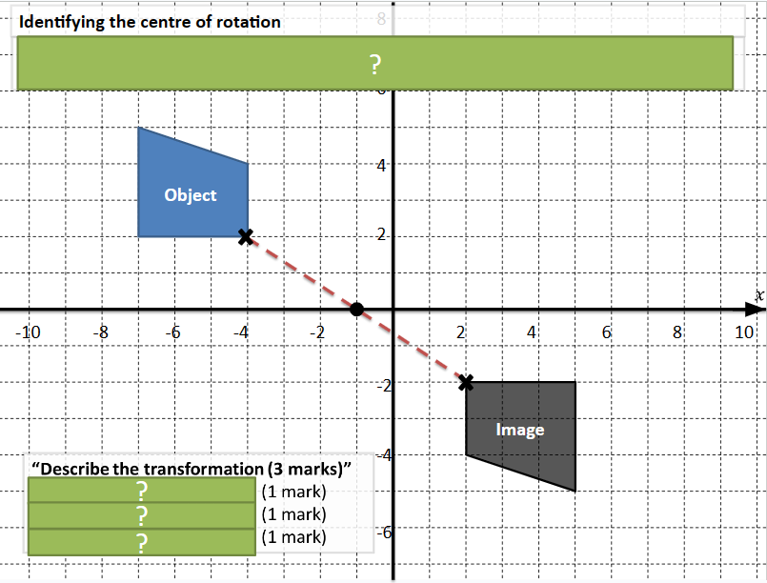
Addressing gaps  SEND learners have a Pupil Passport that informs strategies for learning bespoke to that student.  Staff must make sure they are familiar with the various strategies involved and embed these in their lessons. |  | Deepening knowledge  Give questions where a shape has been transformed twice.

Week/ Lesson  Key Question? | Key knowledge components & Lesson Outcomes  What do students need to know & what should they be able to do? | Pedagogy & Assessment– How do we teach and assess this at Coal Clough Academy? Strategies to support students knowing more & remembering more  Suggested teaching activities & resources including ‘non-negotiables’ for delivery e.g. minimum of two assessment style questions per week, minimum of one practical per week…
Week 4/ Lesson 3 and Week 5/Lesson 1 | What are the key knowledge components students must be taught this lesson?  - I know what a vector is.  - I know what a translation is.  - I can describe a translation using a vector.  - I can translate a shape by a given vector. Given a transformation I can decide whether it is a reflection, rotation or a translation and provide reasons.  What are the learning outcomes for this lesson?  - Translating a shape by a given vector  Key Questions:  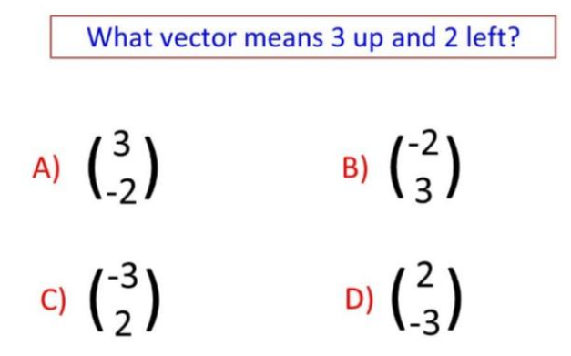  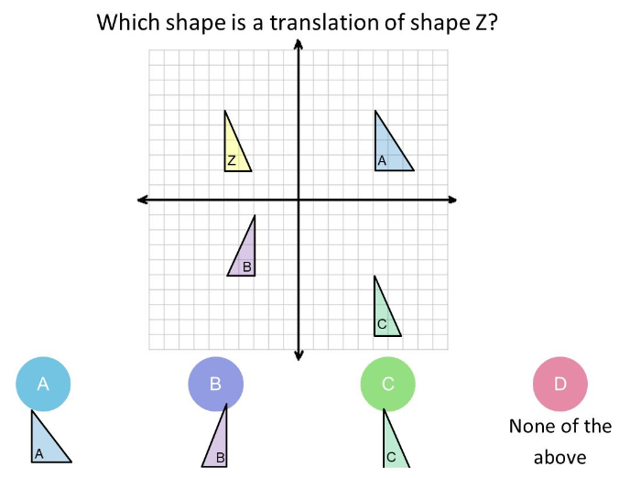 | Key vocabulary for this lesson & how it will be introduced?  Transformation, reflection, rotation, translation, translate, vector, magnitude  Recall activity: 4 Qs (last lesson, last week, last month, last topic); Use questions from assessments (informal and formal) and QLA.  Suggested teaching activities, pedagogy and assessment to inform next steps:  Start by describing the translations in words before introducing vectors.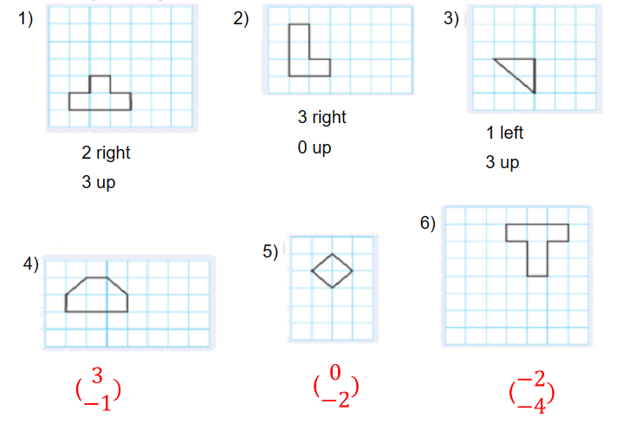  Teach students that a translation is a form of transformation where the shape is just moved. We describe how we move it using a vector eg  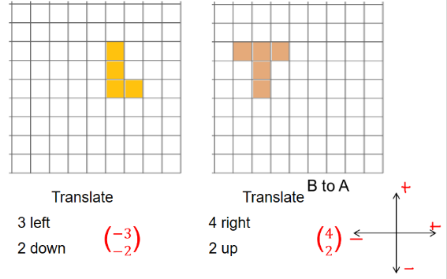  Give students practice at both translating shapes as requested and also describing translations. When describing any transformation firstly the need to state the type eg translation, and then if it’s a translation the need to give the vector.
Addressing gaps  SEND learners have a Pupil Passport that informs strategies for learning bespoke to that student.  Staff must make sure they are familiar with the various strategies involved and embed these in their lessons.  Students have a tendency to write a vector as a fraction or as a coordinate and it is neither of these. It describes a size (magnitude) and a direction. Spend time checking that they understand the the number on the top describes how the shape moves horizonatally and the number on the bottom describes how the shape moves vertically. See second diagram in suggested teaching sequence. |  | Deepening knowledge  Give students transformations where 2 transformations have occurred eg first a shape is reflected and then it is rotated.

Week/ Lesson  Key Question? | Key knowledge components & Lesson Outcomes  What do students need to know & what should they be able to do? | Pedagogy & Assessment– How do we teach and assess this at Coal Clough Academy? Strategies to support students knowing more & remembering more  Suggested teaching activities & resources including ‘non-negotiables’ for delivery e.g. minimum of two assessment style questions per week, minimum of one practical per week…
Week 5/ Lesson 2 | What are the key knowledge components students must be taught this lesson?  - I know what a vector is  What are the learning outcomes for this lesson?  - Representing vectors visually and numerically  Key Questions:  How would I draw this vector?  How do I know which direction it is going?  Which is the correct way to write this vector?  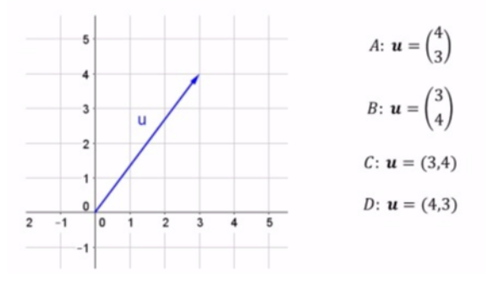  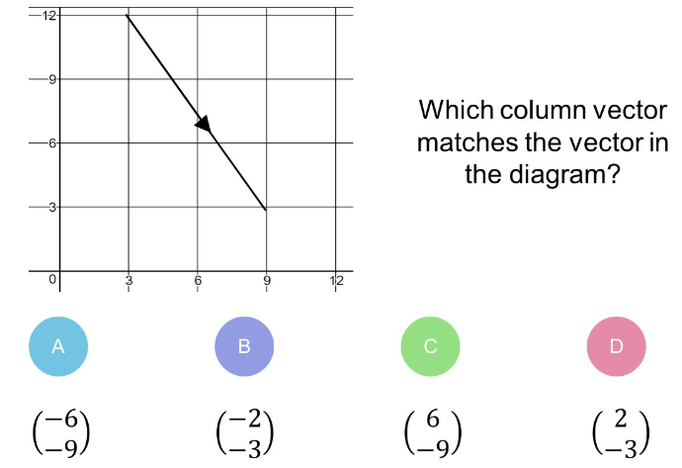 | Key vocabulary for this lesson & how it will be introduced?  Vector, scalar, magnitude  Recall activity: 4 Qs (last lesson, last week, last month, last topic); Use questions from assessments (informal and formal) and QLA.  Suggested teaching activities, pedagogy and assessment to inform next steps:  Start by getting students to describe a visual of a vector mathematically. They need to understand vectors have a magnitude and a direction. The directions on the visuals are shown by the arrows.  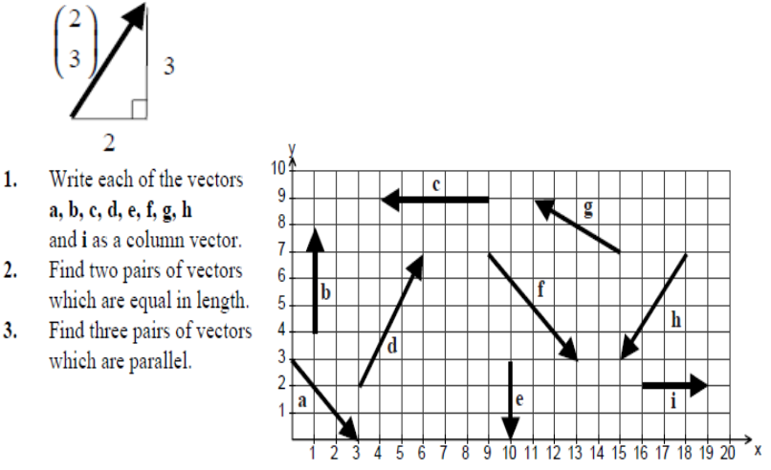  Next, give them vectors and get them to draw them visually  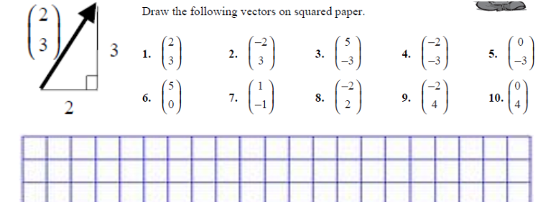
Addressing gaps  SEND learners have a Pupil Passport that informs strategies for learning bespoke to that student.  Staff must make sure they are familiar with the various strategies involved and embed these in their lessons. |  | Deepening knowledge

Week/ Lesson  Key Question? | Key knowledge components & Lesson Outcomes  What do students need to know & what should they be able to do? | Pedagogy & Assessment– How do we teach and assess this at Coal Clough Academy? Strategies to support students knowing more & remembering more  Suggested teaching activities & resources including ‘non-negotiables’ for delivery e.g. minimum of two assessment style questions per week, minimum of one practical per week…
Week 5/ Lesson 3 | What are the key knowledge components students must be taught this lesson?  - I know what a vector is  What are the learning outcomes for this lesson?  - Changing the direction and magnitude of a vector visually and numerically  Key Questions:  How do I know what direction the vector is going? How do I show this in the vector?  How do I know how big it is? | Key vocabulary for this lesson & how it will be introduced?  Vector, scalar, magnitude  Recall activity: 4 Qs (last lesson, last week, last month, last topic); Use questions from assessments (informal and formal) and QLA.  Suggested teaching activities, pedagogy and assessment to inform next steps:  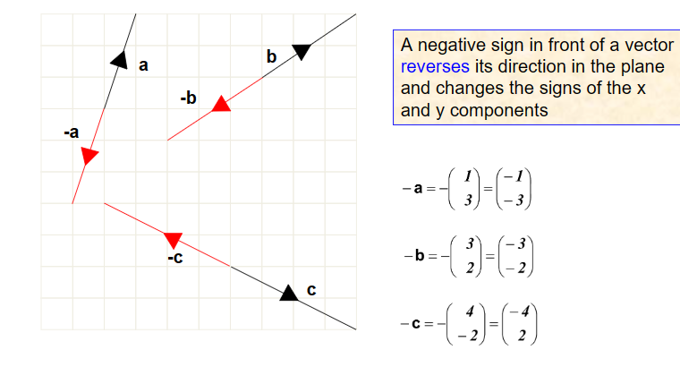  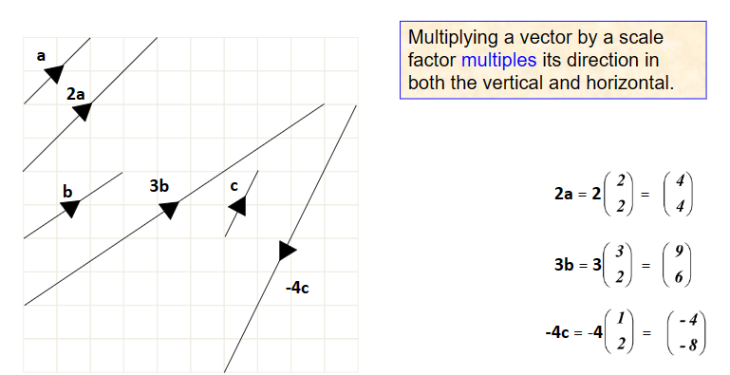
Addressing gaps  SEND learners have a Pupil Passport that informs strategies for learning bespoke to that student.  Staff must make sure they are familiar with the various strategies involved and embed these in their lessons. |  | Deepening knowledge

Week/ Lesson  Key Question? | Key knowledge components & Lesson Outcomes  What do students need to know & what should they be able to do? | Pedagogy & Assessment– How do we teach and assess this at Coal Clough Academy? Strategies to support students knowing more & remembering more  Suggested teaching activities & resources including ‘non-negotiables’ for delivery e.g. minimum of two assessment style questions per week, minimum of one practical per week…
Week 6/ Lesson 1 | What are the key knowledge components students must be taught this lesson?  - I know what a vector is  What are the learning outcomes for this lesson?  - Vector addition and subtraction  Key Questions:  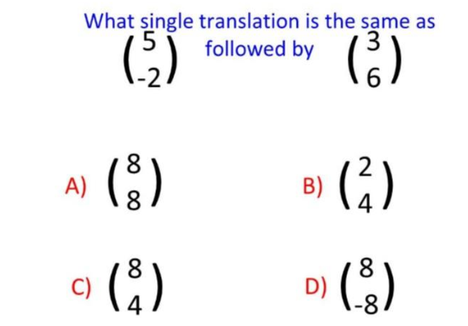 | Key vocabulary for this lesson & how it will be introduced?  Vector, scalar, magnitude, resultant vector  Recall activity: 4 Qs (last lesson, last week, last month, last topic); Use questions from assessments (informal and formal) and QLA.  Suggested teaching activities, pedagogy and assessment to inform next steps:  Link vector addition/subtraction to transformations in that it is one translation followed by another. See first key question.  Teach vector addition and subtraction diagrammatically as well as using vectors eg 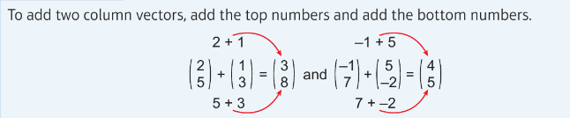  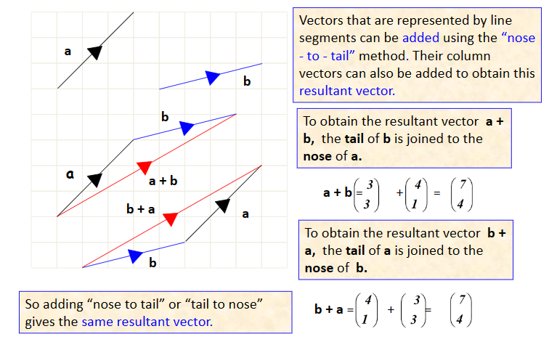  Give questions of increasing complexity with both vectors and diagrams  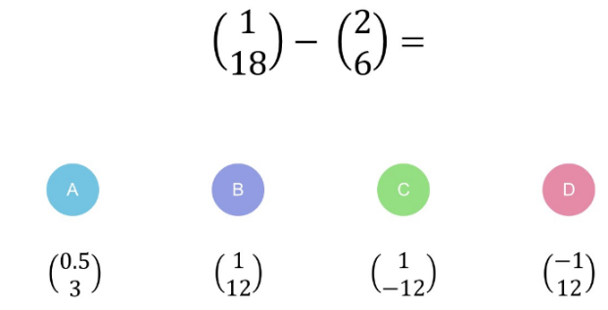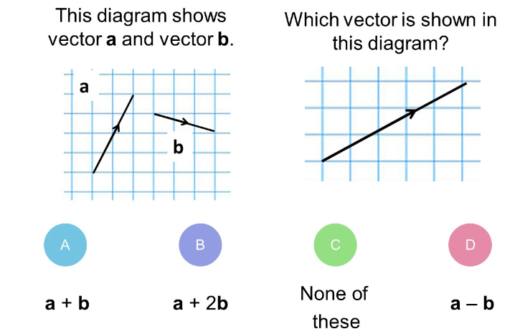
Addressing gaps  SEND learners have a Pupil Passport that informs strategies for learning bespoke to that student.  Staff must make sure they are familiar with the various strategies involved and embed these in their lessons. |  | Deepening knowledge  Take away the visual so that students have to use a coordinates grid to solve questions:  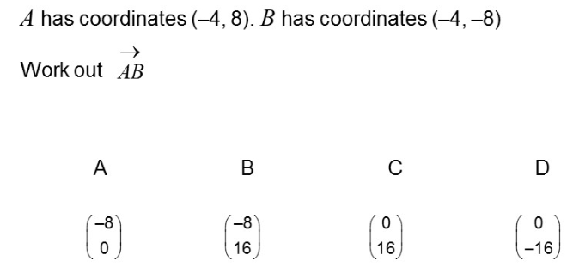

Week/ Lesson  Key Question? | Key knowledge components & Lesson Outcomes  What do students need to know & what should they be able to do? | Pedagogy & Assessment– How do we teach and assess this at Coal Clough Academy? Strategies to support students knowing more & remembering more  Suggested teaching activities & resources including ‘non-negotiables’ for delivery e.g. minimum of two assessment style questions per week, minimum of one practical per week…
Week 6/ Lesson 2 | What are the key knowledge components students must be taught this lesson?  - I know what a vector is  What are the learning outcomes for this lesson?  - Multiplying a vector by a scalar  Key Questions:  Which is correct and why?  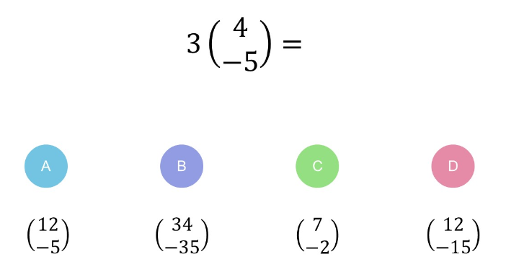  What is 4p as a resultant vector?  What is 2q as a resultant vector?  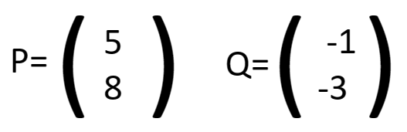 | Key vocabulary for this lesson & how it will be introduced?  Vector, scalar, magnitude, resultant vector  Recall activity: 4 Qs (last lesson, last week, last month, last topic); Use questions from assessments (informal and formal) and QLA.  Suggested teaching activities, pedagogy and assessment to inform next steps:  Teach vector multiplication by a scalar both using vectors and diagrammatically eg., 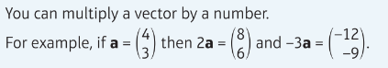  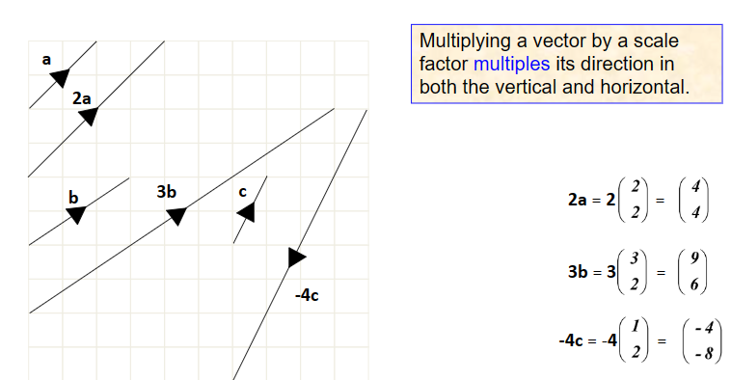
Addressing gaps  SEND learners have a Pupil Passport that informs strategies for learning bespoke to that student.  Staff must make sure they are familiar with the various strategies involved and embed these in their lessons. |  | Deepening knowledge

